

SCHOOL OF INFORMATION SCIENCE AND TECHNOLOGY
DEPARTMENT OF SOFTWARE ENGINEERING
PROJECT TITLE: HIT200

TAKURABID

A DIGITAL FREIGHT MARKETPLACE SYSTEM
SUBMITTED BY:

NAME | REG NO
MATIPA BRAVE MACHANGU | H240240P
EDITH MUYAMBIRI | H240577T
PRINCESS B KWANIYA | H240301V
NYASHA NYEKETE | H240167Z
SUPERVISOR: MR MUROVE
DATE: 26 FEBRUARY 2026

Abstract
TakuraBid is a proposed digital freight marketplace designed to transform Zimbabwe’s trucking and logistics sector. Existing research and industry analysis reveal inefficiencies, high costs, trust deficits, and limited technological adoption in the freight industry. Traditional logistics companies operate on closed systems, leaving independent drivers and small to medium businesses underserved. TakuraBid addresses these gaps by introducing a web and mobile platform that connects shippers and verified drivers in real time. The system integrates features such as KYC-based verification, driver ratings, secure escrow payments, and instant matching powered by AI driven recommendations. Unlike traditional providers, TakuraBid empowers individual drivers, enhances transparency, and broadens access to logistics services for corporates, SMEs, and individuals alike. This documentation outlines the background research, system design, and implementation strategies, demonstrating how TakuraBid fills a critical gap in Zimbabwe’s freight ecosystem.

Preface
This documentation is the outcome of extensive research, collaboration, and innovation undertaken by the TakuraBid team. The project was inspired by the pressing need to modernize freight logistics in Zimbabwe and align it with global best practices in digital marketplaces. Through a combination of literature review, company analysis, and stakeholder consultations, we identified the existing inefficiencies and conceptualized a platform tailored to local realities.
The document is structured to present a clear understanding of the problems within Zimbabwe’s logistics sector, the gaps in current systems, and the innovative solutions that TakuraBid introduces. It is our hope that this work not only contributes academically but also serves as a foundation for real-world implementation that will improve efficiency, foster trust, and create opportunities for drivers and businesses across Zimbabwe.

Acknowledgements
The successful completion of this project would not have been possible without the guidance, support, and contributions of many individuals and groups.
We express our sincere gratitude to our panel members, whose constructive feedback and insights greatly shaped the development of TakuraBid. We also extend our appreciation to the lecturers we consulted Mrs Amos, Mr Manjoro, and Mr Duri for their invaluable mentorship, encouragement, and critical reviews that ensured the system was both practical and effective.
A special thank you goes to the TakuraBid Team, whose commitment, creativity, and collaboration brought this idea to life:
- Matipa Brave Machangu
- Princess Batsirai Kwaniya
- Nyasha Nyekete
- Edith Muyambiri
Together, this effort stands as a testament to what teamwork, research, and innovation can achieve. To all who contributed directly or indirectly, we remain deeply grateful.

DEDICATION
We dedicate this work to our families for their endless support, patience, and encouragement throughout our academic journey. Their belief in our potential has been our driving force.
We also dedicate this project to the innovative spirit of Zimbabwe’s youth and to the hard-working truck drivers who form the backbone of our economy. May this platform one day serve to make their lives easier and their businesses more prosperous.

DECLARATION
We, the undersigned, hereby declare that this project report titled "TAKURABID: A DIGITAL FREIGHT MARKETPLACE SYSTEM" is our own original work and has not been submitted to any other university or institution for the award of a degree. All sources of information used have been duly acknowledged and referenced

CHAPTER ONE: INTRODUCTIOjN

1.1 Background of the Study
Transportation remains one of the most critical yet challenging aspects of Zimbabwe's economy. All major industries in the country including mining and minerals, agriculture, manufacturing, tourism, energy, and power share one fundamental need: the reliable movement of goods. From transporting maize across provinces to delivering household furniture and industrial equipment, the logistics sector underpins virtually every economic activity. In 2023, transport services contributed 53% of Zimbabwe's commercial service exports, highlighting their central role in national trade and economic development. According to NewsDay, the freight market was valued at USD 9.47 billion in 2024 and is projected to grow to USD 16.84 billion by 2034, confirming that freight and transport are not merely support services but a core driver of Zimbabwe's economic future.
Despite this significant market size and growth trajectory, the freight industry in Zimbabwe remains highly fragmented and inefficient. The majority of transport operators are independent truck owners or small fleet operators who struggle to find consistent loads, while clients ranging from large mining corporations to small-scale farmers and individual consumers face difficulties in finding reliable, trustworthy transporters. Currently, most freight transactions are facilitated through informal networks, word-of-mouth referrals, broker intermediaries, or roadside loading zones. These traditional methods are plagued by several challenges: lack of price transparency, limited trust between parties, difficulty verifying driver and vehicle credentials, and significant delays in matching available trucks with available cargo. This inefficiency results in a high rate of empty return trips (deadhead mileage), which increases operational costs, reduces profitability for drivers, and ultimately leads to higher prices for clients.
Furthermore, the absence of a regulated digital marketplace has created an environment where fraudulent activities can occur. Clients have reported cases of paying for services that were never delivered, while drivers have experienced non-payment after completing deliveries. The lack of accountability mechanisms, such as secure payment holding and verified driver profiles, perpetuates a cycle of mistrust that hinders the industry's full potential.
The Takura-bid System has been conceptualized as a digital solution to these persistent challenges: a web-based freight marketplace platform that connects clients with trusted truck drivers in real time. By enabling transparent bidding, secure payments, and verified driver profiles, the platform aims to build trust, reduce empty trips, and create fair opportunities for all stakeholders in Zimbabwe's transport sector. Through Takura-bid, clients can post available loads, drivers can bid competitively for jobs, and both parties can transact within a secure environment that includes payment protection and verified credentials.
By leveraging modern web technologies, the system seeks to transform Zimbabwe's fragmented freight industry into an efficient, transparent, and reliable digital ecosystem that benefits drivers, clients, and the broader economy.

1.2 Problem Statement
The central problem in Zimbabwe's freight sector is the lack of an efficient, transparent mechanism to connect cargo owners with available transporters. Despite the industry's significant contribution to the national economy valued at USD 9.47 billion in 2024, the process of matching loads with trucks remains largely fragmented and informal. This critical gap has created a chain of systemic issues that undermine the sector's efficiency, profitability, and growth potential:
Broker & Middleman Fraud: Unregulated intermediaries exploit the lack of direct connection between drivers and clients, increasing the risk of scams and financial loss for both parties. These middlemen often charge exorbitant fees or disappear after collecting payments, leaving drivers unpaid and cargo owners without service.
Operational Inefficiency: A high volume of empty return trips particularly common on intercity routes significantly drives up fuel consumption and operational costs. Trucks frequently travel back to their origin points without cargo, wasting resources and contributing to unnecessary carbon emissions while reducing overall industry profitability.
Financial Instability: Local transporters often face late payments and cash flow disputes due to informal arrangements. Without formal contracts or secure payment mechanisms, drivers may wait weeks or months for payment, while cargo owners worry about paying upfront for services that may not be delivered as agreed.
Unfair Pricing: The absence of a standardized rate system leads to pricing disputes and reduced profit margins for stakeholders. Drivers may underbid out of desperation, only to find the job unprofitable, while clients may overpay due to lack of market transparency. This inconsistency erodes trust and makes it difficult for legitimate operators to sustain their businesses.
Lack of Trust: The industry suffers from significant trust deficits on multiple fronts. Scam drivers occasionally steal goods or load items not agreed upon by the owner, while fraudulent clients may refuse payment after delivery. Inconsistent load distribution where some trucks return empty while others are dangerously overloaded further degrades confidence in the sector.
Manual Systems: The continued reliance on phone calls, physical notice boards, WhatsApp groups, and paper-based processes limits real-time coordination and scalability. These outdated methods cannot support the growing demand projected to reach USD 16.84 billion by 2034, leaving the industry ill-prepared for future growth.
These interconnected challenges create a vicious cycle of inefficiency and mistrust that stifles innovation, limits economic opportunities, and prevents Zimbabwe's freight sector from realizing its full potential as a driver of national development.

1.3 Objectives
The primary goal of TakuraBid is to develop a digital logistics platform that directly connects truck drivers and clients, thereby eliminating middlemen and informal arrangements while creating a transparent, efficient marketplace for Zimbabwe's freight sector.
SMART Objectives:
1. To establish trust and accountability within the sector by implementing verified driver profiles, rating systems, and transparent service histories that allow clients to make informed decisions based on past performance and credentials.
2. To introduce a fair bidding mechanism that empowers drivers to compete for jobs based on pricing, availability, and reliability, while enabling clients to select the best offer that meets their budget and delivery requirements.
3. To reduce the environmental impact of the logistics sector by minimizing empty return trips through intelligent load matching, thereby lowering fuel consumption, reducing carbon emissions, and optimizing vehicle utilization across the country.
4. To enable real-time tracking of trucks during transit through GPS integration, providing clients with complete visibility and security for high-value cargo while allowing drivers to share their location and estimated arrival times automatically.
5. To facilitate seamless, secure communication between drivers and clients through integrated in-app messaging and calling features, ensuring all negotiations and coordination occur within a documented, auditable environment.
6. To create a secure digital payment ecosystem that protects both parties by holding funds in escrow until delivery is confirmed, eliminating late payments and reducing the risk of financial disputes or fraud.
7. To develop an analytics dashboard that provides insights into market rates, load patterns, and driver performance, enabling stakeholders to make data-driven decisions and contributing to the gradual standardization of freight pricing.

1.4 Hypothesis
It is hypothesized that by replacing unregulated intermediaries with a transparent, AI-driven digital marketplace, the TakuraBid platform will significantly reduce fraud, lower operational costs through route optimization, and increase the profitability of independent truck drivers in Zimbabwe.

1.5 Justification
The development of TakuraBid is justified by the critical need to modernize Zimbabwe's logistics infrastructure.
- Economic Necessity: With the freight market projected to reach USD 16.84 billion by 2034, digital intervention is required to sustain growth and handle increasing demand.
- Social Impact: The platform empowers individual drivers and SMEs by creating fair opportunities and removing exploitative middlemen.
- Efficiency & Sustainability: By optimizing routes and reducing empty return trips, the platform addresses fuel waste and carbon emissions, contributing to environmental sustainability.

1.6 Proposed Tools
The project will be implemented using a robust, modern technology stack designed for scalability, type safety, and security.
- Application Framework and Frontend

- Next.js 16.1.4 (App Router): Serves as the core full-stack framework, handling server and client rendering, API route handlers, and Edge Middleware.
- React 19.2.3: Powers the UI runtime, managing Client Component interactivity and state via the Context API.
- TypeScript 5.9.3: Provides end-to-end static typing across server and client code to ensure code reliability and maintainability.
- User Interface and Styling
- Tailwind CSS 3.4.19: A utility-first CSS framework used for rapid styling, with custom component classes defined in global.css
- PostCSS + Autoprefixer: Ensures cross-browser CSS compatibility and optimization.
- Backend and Database
- Supabase PostgreSQL: A hosted PostgreSQL database used for structured data management, featuring an auto-generated REST API layer via PostgREST.
- Supabase JS SDK 2.97.0: Utilized as a typed query builder to interact securely with the PostgreSQL database.

- Artificial Intelligence
- Python: Dedicated to running the AI models that power the price recommendation engine and smart driver matching algorithms.
- Development and Build Tooling
- Next.js SWC Compiler: A Rust-based tool for high-performance transpilation and bundling, replacing older tools like Babel.
- ESLint + TypeScript ESLint: Enforces code quality through static analysis and type-aware linting rules.
- Security Infrastructure
- Encryption: AES-256 encryption is implemented for data protection at rest and in transit.
- Real-Time Security: Secure WebSockets are used for encrypted real-time updates (tracking and bidding).
- Payments: Tokenized payment gateways are integrated to handle financial transactions securely.

1.7 Feasibility Study
Technical Feasibility The project utilizes established technologies (React, Node.js, Python) supported by a clear architecture that includes secure login, load posting, and bidding systems. Security measures such as hashed passwords and encrypted data transmission ensure the system is technically viable and secure for financial transactions.
Economic Feasibility The project targets a high-value market contributing over 50% to Zimbabwe's commercial service exports. By reducing the cost of "empty legs" (return trips without cargo) and eliminating broker fees, the platform offers clear financial incentives for adoption by both drivers and shippers.

Operational Feasibility The operational plan includes a pilot test with a small group of drivers and customers to validate the system before full-scale launch. The platform is designed to be user-friendly to encourage adoption among drivers who currently rely on manual phone-based systems.

1.8 Project Plan (Gantt Chart)
Time Plan
Phase | Activity | Duration | Description
Phase 1: Development | Core Implementation | 4 AUG 2025 - 5 SEP 2025 | Development of Frontend (React.js) and Backend (Node.js) architecture.
 | AI Integration | 8 SEP 2025 - 31 OCT 2025 | Implementation of Python-based AI models for price recommendation and driver matching.
 | Database Setup | 20 OCT 2025 - 21 NOV 2025 | Configuration of MySQL database for managing user profiles and bids.
Phase 2: Testing | Pilot Testing | 30 NOV 2025- 12 JAN 2026 | Deployment to a small group of drivers and customers for real-world feedback.
 | Security Audits | 12 JAN 2026 - 19 FEB 2026 | Verification of AES-256 encryption and secure payment gateways.
Phase 3: Scaling | Payment Integration | 16 FEB 2026 - 13 MAR 2026 | Full integration of payment systems (PayPal/EcoCash).
 | Route Optimization | 10 MARCH 2026 - 17 APR 2026 | Activation of advanced route optimization features for efficiency.

Gantt Chart

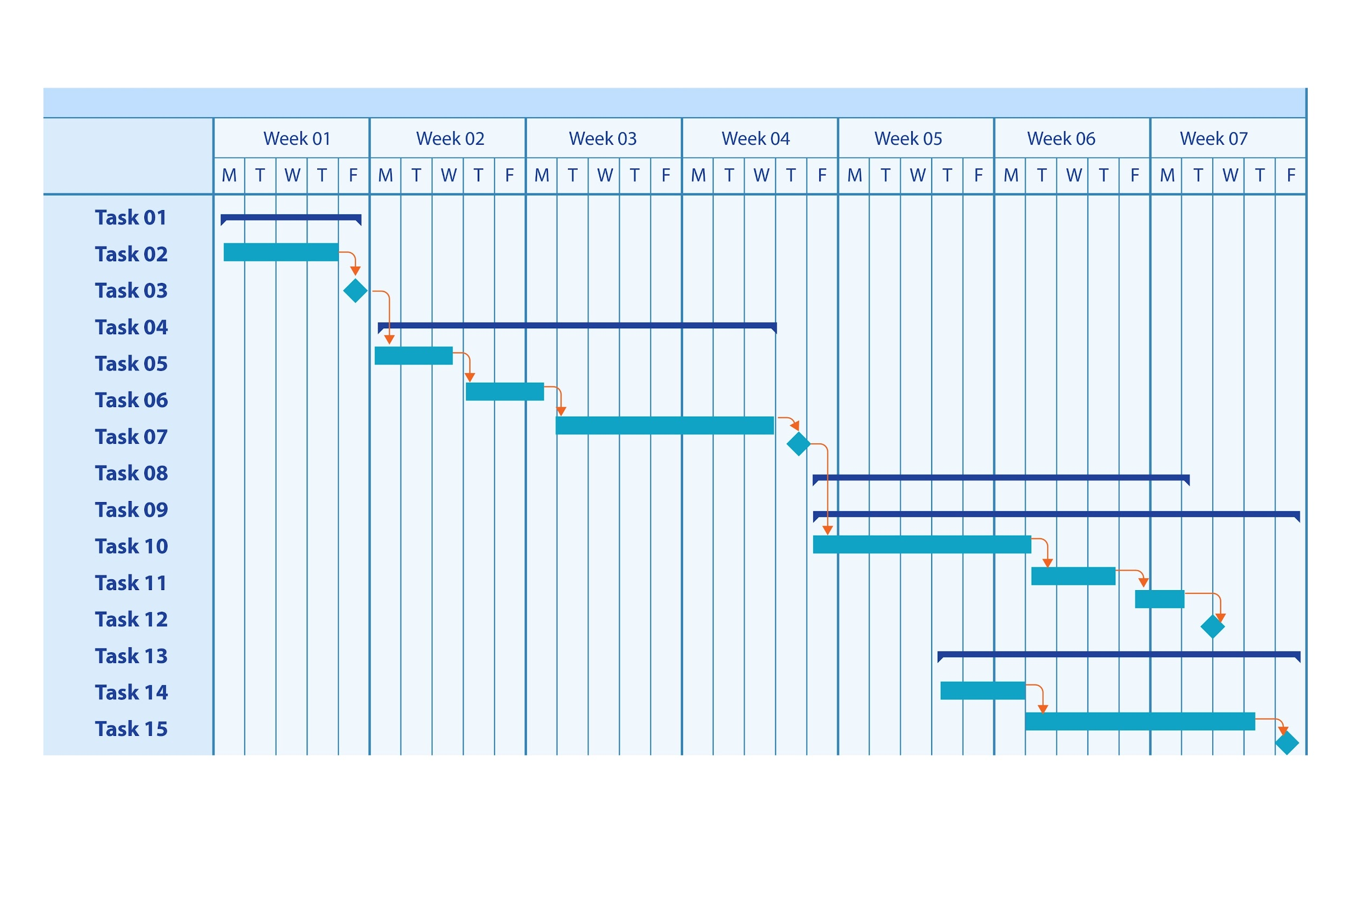
CHAPTER TWO-LITERATURE REVIEW

LITERATURE REVIEW FOR TAKURA-BID [ RESEARCH PAPERS ]

2.1 Introduction
As Takura-Bid, we have conducted an in-depth review of academic and industry research to understand the global and local developments in logistics, freight marketplaces, and platform-based business models. This literature review examines eight key research papers, highlighting their contributions, solutions, and future work, while identifying the gaps that remain. These gaps directly inform and justify the innovation that Takura-Bid introduces into Zimbabwe’s trucking and logistics sector.

2.2 Review of Research Papers

Author(s) | Title / Year | Techniques | Problem Statement | Solution Proposed | Future Work | Research Gap
Leah Davis & Joseph Lucido | Innovative Transportation Solutions: Uber for Freight (2022)  View Document | Algorithm-based applications for matching & payments | Middlemen in freight cause inefficiencies. | Platform to automate matching, updates, and payments. | Explore applications for sensitive industries (perishables, defense, medical). | Focuses on developed contexts; lacks application to emerging market like Zimbabwe.
Kelvin Reigns & Joyce Smith | Smart Mobile Application for Short-Haul Cargo Transportation (2023)  View Doc | Design Thinking & ICT | Miscommunication and lack of coordination among stakeholders. | ICT-based mobile app for trucking companies and customers. | Expand to crowd-shipping (co-transporting parcels & passengers). | Does not address long-haul freight challenges or informal trucking sectors in Africa.
Christoph Heinbach, Pascal Meier & Oliver Thomas | Shared Freight Service Intelligence Platform (2022)  Cit | Design Science + Mobile Telematics | Lack of shared data-driven freight service intelligence. | Collaborative Freight Service Intelligence Platform. | Improve predictive analytics & automation, ensure secure collaboration. | Solution depends heavily on advanced telematics; not easily adaptable to low-resource environments like Zimbabwe.
Prof M. Tukuta & Prof M. Tsvere | Transport Costing & Competitiveness: Zimbabwe Road Freight (2023)  Link | Quantitative survey of 384 firms | Lack of transport costing knowledge in Zimbabwe’s freight sector. | Emphasized the importance of costing for efficiency & pricing. | Include transport costing in Zimbabwe’s education curriculum. | Does not propose practical digital solutions to improve efficiency in freight operations.
Oana Dinu, Eugen Roşca & Ştefan Burciu | Platform-Based Business Models for Climate Neutrality in Logistics (2024)  View Document | Conceptual framework (business model + sustainability) | Logistics platforms lack integration with climate goals. | Framework linking platform models with decarbonization. | Apply in low-emission multimodal freight strategies. | Focus is on sustainability; does not tackle payment security or trust issues faced in African freight markets.
Juan Martinez & Aisha Khan | Digital Freight Marketplaces in Emerging Economies (2021)  View Document | Case studies (India, Kenya) | Informal trucking markets lack transparency & secure payments. | Freight platforms with ratings, escrow, and bidding. | Study adoption barriers in African contexts. | No case study directly focused on Zimbabwe; highlights opportunity for local adaptation.
Robert Moyo | Challenges of Road Freight in Zimbabwe (2020)  View Document | Mixed-methods, interviews with 50 operators | Zimbabwean truckers face inefficiency, poor regulation, and high operational costs. | Recommend digital systems for transparency, route optimization, and secure payments. | Pilot tech-driven platforms in Zimbabwe’s trucking sector. | Does not provide a tested, scalable marketplace model for Zimbabwe.
Lin, Chen & Wu | Trust Mechanisms in Online Freight Platforms (2022)  View Document | Qualitative study of platform governance | Lack of trust between shippers and drivers hinders adoption. | Ratings, verified profiles, escrow, and dispute resolution as core governance features. | Explore cultural trust dynamics in emerging markets. | Trust models examined are mostly from Asia; limited insight into Zimbabwe’s socio-economic context.

2.3 Insights from Literature
- Global trend: Digital freight platforms improve transparency, cut costs, and automate inefficiencies.
- Zimbabwe context: Local studies (Tukuta & Tsvere, Moyo) confirm inefficiencies, poor costing practices, and weak technology adoption.
- Key themes:
• Platforms build trust via verified profiles, ratings, and secure payments.
• ICT tools solve coordination problems in fragmented markets.
• Platform-based models enable sustainability and scalability.

2.4 Research Gap
Despite global advances in digital freight platforms, Zimbabwe lacks a dedicated, trust-based, real-time freight marketplace. Existing players (Bulwark, Swift, Speedlink) operate as traditional logistics providers, not open platforms. Research confirms trust gaps (Lin et al., 2022), coordination failures (Reigns & Smith, 2023), and lack of costing & efficiency practices in Zimbabwe (Tukuta & Tsvere, 2023; Moyo, 2020). The gaps in the reviewed research highlight the need for a platform like Takura-Bid that addresses local realities and creates a sustainable ecosystem for all stakeholders.

2.5 Conclusion (Link to Takura-Bid)
The reviewed literature demonstrates that while digital freight innovations are advancing globally, Zimbabwe remains underserved. Takura-Bid directly addresses this research gap by introducing a multi-sided freight marketplace built on trust, transparency, and inclusivity, tailored to Zimbabwe’s unique logistics challenges.

CHAPTER THREE: ANALYSIS
3.1 Information Gathering Tools
To understand the current state of the freight logistics sector in Zimbabwe and define the requirements for TakuraBid, the following information gathering methodologies were utilized:
- Literature Review: A comprehensive review of existing platforms and studies was conducted, including comparisons with traditional logistics providers like Speedlink Cargo, Swift Transport, and Bulwark Transport. This also included analysis of industry reports such as the "Zimbabwe digital freight brokerage market report 2025-2031" and academic papers on auction-based pricing mechanisms.
- Market Observation & Document Analysis: Analysis of informal communication channels (chat logs) revealed systemic issues such as late payments, broker fraud, and lack of transparency.
- Quantitative Data: Reference was made to existing surveys, such as the study by Prof. Tukuta & Prof. Tsvere involving 384 firms, which highlighted the lack of transport costing knowledge in the sector.

3.2 Description of System

System Description
The proposed system, Takura-Bid, is a digital freight matchmaking platform designed to connect clients with independent truck drivers in a secure, transparent, and efficient marketplace. Unlike traditional logistics companies that rely on middlemen and internal allocation, Takura-Bid empowers users with direct peer-to-peer interactions, reducing inefficiencies and costs.

Core Components
- User Profiles:
Clients can post loads, track deliveries, communicate with drivers, and make payments. Drivers can create profiles, bid for loads, view assigned deliveries, and receive payments. Lastly, administrators manage users, monitor system activity, generate reports, and enforce security.

- Load Posting & Bidding:
Clients submit load requests with pickup and destination details. Drivers place bids, enabling a competitive and transparent pricing mechanism. The system recommends base pricing and best driver matches using algorithmic support.

- Matching & Pricing
Instead of relying on middlemen, the system uses OpenAI’s GPT-4o API to analyze data such as distance, vehicle type, and past transactions to recommend a base price to the client. Using LangChain pipelines, the system integrates live platform data like available (online) drivers, ratings, and proximity to suggest the best driver for the job.

- Real-Time tracking & notifications
Google Maps APIs enable GPS tracking of deliveries. Instant notifications will keep clients and drivers updated on delivery progress.

- Payments
The system charges a transaction fee per completed booking, ensuring the platform remains simple.

- DashBoards & Analytics
Every user (client, driver, admin) will have access to a personalized dashboard. Dashboards display completed trips, bids, earnings, ratings, and system analytics. Administrators will use Power BI for monitoring platform trends and generating compliance reports.

To understand the current logistics workflow and identify inefficiencies, we analyzed the existing freight system used by major players in Zimbabwe. The Data Flow Diagrams (DFDs) illustrate how data moves within the current setup. This analysis highlights gaps that TakuraBid will address.

How the current system works:
- Shippers request transport by phone/email.
- Logistics companies manually record requests.
- Admins assign drivers internally, often without transparency.
- Drivers confirm delivery only through communication with the company.
- Payments are invoice-based, delayed, and not instant.
Problems identified:
- Manual and slow processes.
- Lack of transparency and visibility for shippers.
- Independent drivers excluded.
- Delayed payments, weak trust.
3.3 Data analysis - UML context diagrams
DFD of existing system

DFD Level 0 (Context Diagram)

The Level 0 DFD shows the overall interaction between shippers, the logistics company, and drivers. Data flows include shipment requests, job assignments, delivery confirmations, and invoices

3.4.1 DFD (Level 0) of Existing Freight System
The system interfaces with three main external entities:
Shipper/Client: Individuals or businesses who need goods transported. They initiate the process by requesting shipments and ultimately receive invoices and make payments upon successful delivery.
Driver: Transport service providers who are assigned jobs and are responsible for delivering goods. They receive job assignments and provide delivery confirmations back to the system.
Logistics Company: Broader transport firms that may book shipments through the platform and assign jobs to their drivers within the system.

Data Flows
From Shipper/Client to System: Request Shipment: Client submits load details including pickup location, destination, cargo type, and preferred timeline
From System to Shipper/Client: Invoice/Payment: System generates invoices and processes payments upon delivery confirmation
From System to Logistics Company: Book Shipment: System notifies logistics companies of available shipments for their fleet
From Logistics Company to System: Assign Job: Logistics companies assign specific jobs to drivers under their management
From System to Driver:Assign Job: Drivers receive job assignments directly or through their logistics company
From Driver to System: Delivery Confirmation: Drivers confirm successful delivery, triggering payment processing

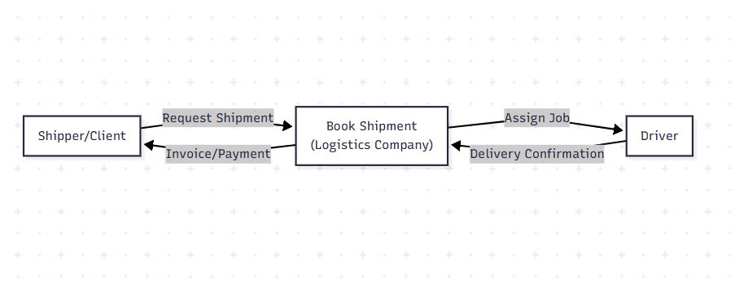

3.4.2 UML Context Diagram of Existing Freight System

Customer: Individuals or businesses needing freight services. They initiate contact with brokers or drivers directly via phone calls or messages, providing load details and negotiating prices informally.
Transport Broker: Intermediaries who match customers with drivers for a fee. They receive load requests from customers and driver availability information, facilitating rate negotiations and coordinating pickup instructions.
Driver / Transport Company: Service providers who transport goods. They communicate availability and vehicle details to brokers, receive load information and pickup instructions, and provide delivery updates through phone calls.
Payment Service: Banks or mobile money platforms that process payments. The system sends payment requests, and customers provide payment confirmations after delivery, though this often happens outside any formal tracking mechanism.

Data Flows
Customer Interactions:
- Load Details and Pickup & Destination information flow from customer to broker/driver
- Negotiated Price flows back to customer upon agreement
Broker Interactions:
- Load Requests and Driver Contacts flow between broker and both customers and drivers
- Matchmaking and Rate Negotiation occur through calls
- Load Information and Pickup Instructions are relayed to selected drivers
Driver Interactions:
- Availability and Vehicle Details flow to brokers
- Manual Bids are communicated verbally
- Driver Info, Price Confirmation, and Delivery Updates flow back to customers/brokers
Payment Flow:
- Payment Request initiated after delivery
- Payment Confirmation received via mobile money or bank notification
This fragmented, manual approach creates inefficiencies, limited transparency, and opportunities for fraud—precisely the problems TakuraBid aims to solve through digitization.

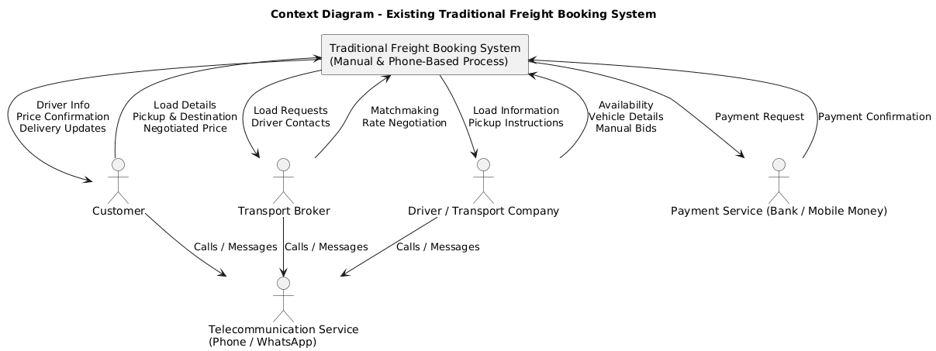

3.5 Evaluation of Alternative Systems

- Global Freight Platforms (Uber Freight)

Uber Freight is Uber’s global logistics platform that helps businesses move goods through trucks, smaller loads, and even parcels.

Strengths
Its main strength is the powerful technology system it offers, which allows shippers to plan, book, track, and pay for deliveries all in one place. This end-to-end system makes logistics easier and more organized. Uber Freight also utilizes Artificial Intelligence (AI) to recommend routes, alert drivers to potential delays, and assist with pricing decisions. In addition, it supports various transportation needs, ranging from full truckloads to small parcel deliveries, and offers customers flexibility with both long-term contracts and one-time bookings. With billions of dollars’ worth of freight and millions of parcels managed every year, Uber Freight is one of the largest platforms in the world, and its ability to connect freight with last-mile delivery makes it advanced.

Weakenesses
However, Uber Freight also faces some weaknesses. Its system is very complex and may be too advanced or difficult for small companies or drivers to use. It depends heavily on having a strong network of carriers and drivers, so if availability drops, performance suffers. Costs and subscription fees can also be high, making it less attractive to small operators. Most importantly, the system is designed for developed countries and assumes access to reliable internet, advanced digital payments, and strong infrastructure factors that make it less suitable for places like Zimbabwe.

Opportunities
At the same time, Uber Freight has opportunities to grow. It could enter emerging markets like Africa by creating simpler versions of its tools. More AI features could help it keep improving pricing, routing, and risk prediction. Partnering with local logistics companies could help them adapt better to different countries. Finally, the rise of e-commerce worldwide means more demand for parcel and last-mile deliveries, an area where Uber Freight is already expanding.

Threats
Despite these opportunities, Uber Freight also faces threats. Strong competition from regional or local companies may limit its ability to dominate new markets, especially in countries where local players understand the market better. Government regulations around transport, labor, and customs are another challenge, especially when operating in multiple countries. Price volatility in freight markets can frustrate customers who expect stable costs, while the “last mile” of delivery remains costly and difficult to manage.

- Traditional Local Systems(Swift Transport, FedEx Cheetah Mobile, Speedlink Cargo)

Strengths
In Zimbabwe, the freight and logistics industry is dominated by established companies like Swift Transport, FedEx Cheetah Mobile, and Speedlink Cargo. These firms are well-known and trusted, with extensive physical infrastructure including depots, vehicles, and dispatch centers. Their main strength lies in reliability and experience, they have been moving goods for years, and many customers trust them for both local and cross-border deliveries. They also handle compliance and customs well, which is important in international logistics. This makes them strong competitors when it comes to established operations.

Weakenesses
However, these traditional systems have a fair share of weaknesses. Most still rely on centralized, dispatcher-based allocation of loads, meaning that customers must depend on company staff to assign drivers rather than being able to interact directly with drivers. This process reduces flexibility and often leads to inefficiency. Pricing is also not very transparent, with customers frequently experiencing inflated or unclear costs. Bookings can be slow and require physical visits or phone calls, making them less convenient compared to digital platforms. Additionally, these companies generally exclude independent drivers, leaving many small operators without access to formal markets.

Opportunities
Despite these issues, there are opportunities for traditional logistics companies to modernize. By digitizing their platforms, introducing real-time tracking, and allowing more customer-driver transparency, they could compete with global digital platforms. Partnerships with independent drivers could also increase their capacity and lower costs. Furthermore, the growth of e-commerce and cross-border trade in Southern Africa creates room for these companies to expand services if they adapt quickly.

Threats
At the same time, they face threats from both international platforms like Uber Freight and local innovations such as Takura-Bid. Customers increasingly expect digital services like instant booking, live tracking, and transparent pricing. Without adapting, traditional companies risk losing younger and more tech-savvy customers. Economic challenges, such as fluctuating fuel prices and currency instability, also put pressure on their operations.

3.6 Functional Analysis of Proposed System
The Functional Requirements specification defines the specific behaviors and functions the TakuraBid platform must support to meet the business objectives of connecting shippers and carriers efficiently.

3.6.1 User Authentication and Profile Management
- FR-01: Secure Registration & Login The system shall allow users (Drivers and Customers) to register and authenticate using secure credentials. This includes support for hashed passwords and optional Two-Factor Authentication (2FA) for enhanced security.
- FR-02: Profile Verification The system shall require drivers to upload verification documents (KYC, vehicle documentation) during onboarding to create a "Verified Profile".
- FR-03: Agency Profiles The system shall support an "Agency Profile" type, allowing fleet owners with more than one truck to manage multiple vehicles and drivers under a single account.
- FR-04: Service History & Ratings The system shall display a comprehensive service history and aggregate rating for each driver, derived from past transaction reviews, to build trust.

3.6.2 Freight and Load Management
- FR-05: Load Posting The system shall allow Customers (Shippers) to post load details, including cargo type, weight, origin, destination, and desired pickup dates.
- FR-06: Load Browsing & Filtering The system shall provide a search interface for Drivers to browse available loads, with filters for route (lane), vehicle type, and cargo requirements.
- FR-07: Real-Time Bidding The system shall enable a transparent bidding mechanism where Drivers can view load details and submit competitive bids in real-time.
- FR-08: Bid Management The system shall allow Customers to view, compare, and accept incoming bids from Drivers based on price, driver rating, and vehicle suitability.

3.6.3 AI & Intelligence Module
- FR-09: Price Recommendation Engine The system shall utilize an AI algorithm to analyze market data and recommend a "fair base price" to Customers at the time of posting to reduce negotiation friction.
- FR-10: Smart Driver Matching The system shall employ an AI model to recommend the best-suited drivers for a specific load based on reliability scores, current availability, and geographic location.
- FR-11: Route Optimization The system shall provide route optimization suggestions to Drivers to minimize empty return trips and reduce fuel consumption.

3.6.4 Communication & Tracking
- FR-12: Real-Time Cargo Tracking The system shall integrate GPS tracking to provide Customers with real-time visibility of their cargo's location during transit.
- FR-13: In-App Communication The system shall provide a secure, integrated messaging and calling interface to facilitate direct communication between the Driver and Customer without revealing personal phone numbers initially.
- FR-14: System Notifications The system shall send real-time notifications (via WebSockets) to users regarding bid status updates, load acceptance, and transit milestones.

3.6.5 Financial & Transaction Management
- FR-15: Secure Payment Gateway The system shall integrate with trusted payment gateways to process transactions, supporting tokenization to ensure sensitive financial data is never stored directly on platform servers.
- FR-16: Escrow Functionality The system shall support an escrow-like payment hold mechanism where funds are secured upon booking and released to the driver upon successful delivery confirmation.
- FR-17: Instant Payouts The system shall support instant payout options (e.g., via EcoCash or PayPal) to improve cash flow for local drivers.

3.7 Functional Analysis : Non-Functional Requirements (NFRs)
The following Non-functional requirements describe the quality attributes and system constraints that ensure TakuraBid operates efficiently, securely, and reliably. Unlike functional requirements which focus on what the system does

1. Performance Requirements
- The system should handle at least 5,000 concurrent users without downtime.
- Response time for core operations like login, booking, bidding should not exceed 3 seconds.
- Mobile and web applications must load within 2 seconds on a 4G or 5G connection.

2. Security Requirements
- All data transmissions must be encrypted using Secure Sockets Layer (SSL) / Transport Layer Security
- Users like drivers and shippers must be verified via KYC (Know Your Customer).
- The system must include two-factor authentication (2FA) for critical operations like payments .
- Data storage must comply with the General Data Protection Regulation standards and local data protection laws.

3. Reliability and Availability
- System uptime should be 99.9% annually.
- Automated backup every 24 hours with restore capability.
- System should support failover mechanisms to ensure continuity in case of server failures.

4. Usability Requirements
- The mobile app must support both Android and iOS with a consistent user interface.
- Interfaces should be multilingual like English + local languages for broader adoption.
- Training materials and in-app tutorials should guide new users.
5. Scalability
- The system must support progressive scaling to accommodate growing users and drivers.
- APIs should be designed to integrate with future services like AI recommendations, external payment gateways, government transport databases

6. Maintainability
- Code should follow modular design principles to simplify updates and bug fixes.
- All changes must be tracked using version control like GitHub or GitLab .
- Documentation must be regularly updated to reflect changes in the system architecture.

7. Interoperability
- Must integrate with popular payment gateways like PayPal, EcoCash, VISA/Mastercard
- Should allow integration with Google Maps API for real-time tracking.
- Future-ready for integration with AI APIs like OpenAI, Google Recommendations AI for recommendations and pricing.

8. Legal and Compliance
- The system must comply with Zimbabwe’s ICT regulatory framework.
- All financial transactions should adhere to Reserve Bank of Zimbabwe (RBZ) requirements.
- Privacy policies must be transparent to users regarding data collection and usage.
3.8 Use-Case Diagram
The TakuraBid platform serves three primary actors: Clients, Drivers, and Administrators, each with distinct responsibilities.
Clients are individuals or businesses requiring freight services. After Registering and Logging in, they Create and Manage their Profile before posting freight jobs. Core client activities include Posting Load Requests, viewing AI-Recommended Prices and Drivers, reviewing bids from drivers, and Selecting the Winning Bid. Once a driver is assigned, clients can Track Deliveries in Real-Time and upon completion, Rate and Review the Driver to maintain accountability.
Drivers are transport service providers who also begin by Registering and Logging in, then Creating and Managing their Profile with vehicle and license details. Their primary function involves Browsing Available Loads posted by clients and Placing Bids on suitable jobs. When a bid is accepted, drivers receive an Accept Job Assignment notification and must Update Delivery Status throughout the journey (pickup, in transit, delivered). They can also view their Earnings Dashboard to track payments and performance.
Administrators oversee platform operations and ensure system integrity. Their responsibilities include Managing Users (activating, suspending, or verifying clients and drivers), Monitoring Transactions to detect suspicious activity, Ensuring Security and Compliance with platform policies, and Generating Reports on platform performance, transaction volumes, and user activity for decision-making purposes.

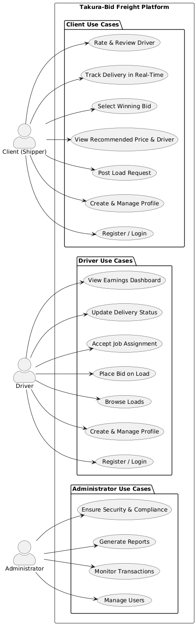fig: 3.8.1

CHAPTER FOUR: DESIGN

4.1 System Diagrams
UML Context Diagram
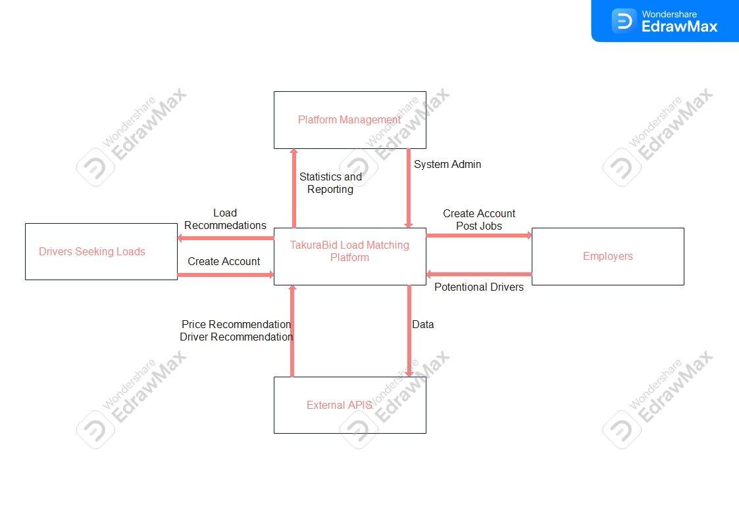

4.1.2 Level 1 - Data Flow Diagram

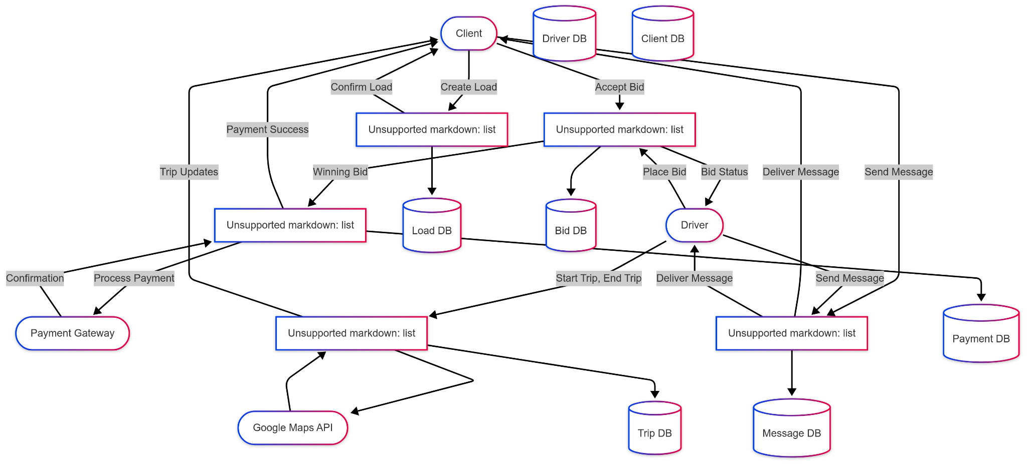

4.1.3 Activity Diagram

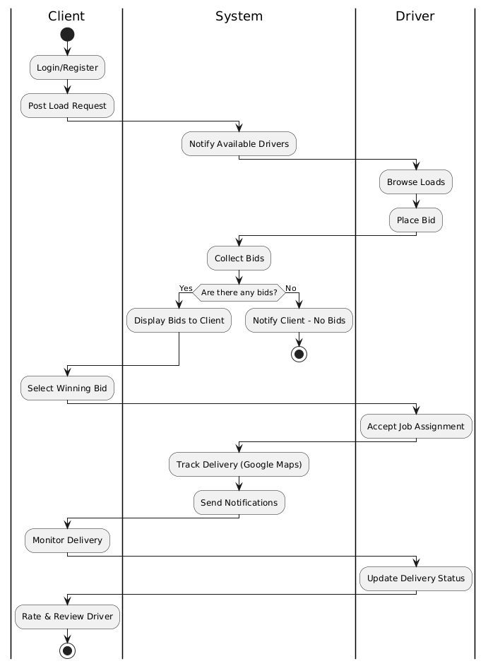

4.2 Architectural Design
4.2.1 Hardware Design

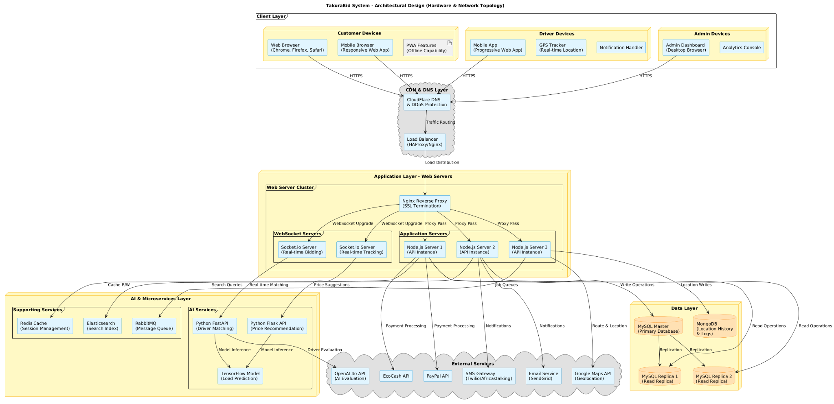

TakuraBid employs a multi-tier distributed architecture designed for scalability, reliability, and real-time performance, enabling the platform to handle varying loads while maintaining responsiveness for critical features such as live bidding and shipment tracking.
The Client Layer accommodates three distinct user categories with tailored interfaces. Customers access the platform via standard web browsers or mobile devices using a responsive Progressive Web App (PWA) that provides app-like experiences including offline access to posted loads. Drivers utilize a mobile-optimized PWA with integrated GPS functionality for real-time location sharing while on the road, along with dedicated notification handling for bid alerts and job assignments. Administrators access a feature-rich desktop dashboard optimized for user management, dispute resolution, and real-time analytics monitoring.
The CDN and DNS Layer provides essential infrastructure services. CloudFlare delivers global DNS resolution, DDoS protection, and static asset caching at edge locations for improved performance. Behind this, an HAProxy or Nginx load balancer distributes incoming traffic across multiple application servers, performs health checks to route away from failed instances, and manages SSL termination to offload encryption overhead.
The Application Layer forms the core of the platform's processing capabilities. An Nginx reverse proxy serves as the entry point for all HTTP and HTTPS traffic, routing API requests to appropriate backend servers while upgrading WebSocket connections for real-time features. Three parallel Node.js application instances handle user authentication, load posting, bidding logic, payment coordination, and administrative operations, with horizontal scaling allowing additional instances as the user base grows. Dedicated Socket.io WebSocket servers manage real-time bidirectional communication, with one server focused on live bidding events and another handling location tracking and delivery updates to ensure critical features remain responsive under load.
The AI and Microservices Layer provides intelligent capabilities through Python-based services. A Flask-based price recommendation service analyzes historical transaction data, current demand, fuel prices, and route distances to suggest fair market rates and reduce pricing disputes. A FastAPI driver matching service evaluates available drivers based on proximity, vehicle capacity, rating history, and current bid amounts to recommend optimal matches for each load. TensorFlow model servers host machine learning algorithms that predict peak demand periods on specific routes, optimal pricing strategies, and driver reliability scores based on historical performance.
Supporting services enhance platform functionality through Redis cache for session management and frequent data caching, Elasticsearch for fast load and driver searches with advanced filtering capabilities, and RabbitMQ message queues that decouple asynchronous processes such as email and SMS notifications, report generation, and payment confirmations.
The Data Layer employs a hybrid database strategy. A MySQL master database handles all write operations including user registrations, load postings, bid submissions, and transaction records, ensuring ACID compliance for financial data. Two MySQL read replicas serve query traffic, with one dedicated to customers browsing loads and driver profiles while the other supports drivers viewing available loads and admin dashboard queries, reducing load on the master database and improving response times. Master-slave asynchronous replication ensures data consistency while maximizing read performance, with automatic failover capabilities. MongoDB stores high-volume, less structured data including GPS location history during trips, system logs, chat messages, and temporary session data, accommodating varying data structures from different devices and logging formats.
The platform integrates with several External Services to deliver complete functionality. Payment processing combines EcoCash API as the primary method for Zimbabwean users with PayPal API for international clients, implementing escrow functionality that holds funds until delivery confirmation to protect both parties. Communication services include SMS gateway integration through Twilio or Africastalking for drivers with basic phones, ensuring bid confirmations and job assignments reach users even with poor internet connectivity, alongside SendGrid email services for detailed receipts and marketing communications. Google Maps API provides geocoding, distance calculations, and visual map rendering for load pickup and delivery points, while OpenAI 4o API augments internal AI services for natural language processing of load descriptions and enhanced driver ranking algorithms.
The architecture incorporates robust security measures including internal service communication over private network segments, database servers accepting connections only from application servers, regular API key rotation for external integrations, AES-256 encryption for sensitive data at rest, TLS 1.3 for all external communications, bcrypt password hashing, and rate limiting with IP blacklisting at the load balancer level.
Scalability is achieved through horizontal scaling across multiple tiers, with additional Node.js instances deployable behind the load balancer, more Socket.io servers with sticky sessions for WebSocket traffic, containerized AI services orchestrated via Kubernetes, additional MySQL read replicas or sharding for database scaling, and expanded Redis clusters for cache capacity.
High availability is ensured through multiple instances at every critical tier eliminating single points of failure, automatic database failover promoting a replica if the master fails, and daily database backups with point-in-time recovery capability to protect against data loss.
This architectural design ensures TakuraBid can reliably serve Zimbabwe's growing freight market, handling peak loads during harvest seasons while maintaining real-time performance for critical bidding and tracking features. The modular design allows for incremental upgrades and technology replacements without disrupting core functionality.
4.2.2 Architectural Design - Networking

High-Level Network Architecture
The TakuraBid platform utilizes a cloud-native architecture hosted on Amazon Web Services (AWS) to ensure high availability, scalability, and security. The network flow is designed to handle distinct traffic types: standard HTTP requests for the web/mobile interface and persistent WebSocket connections for real-time features like bidding and tracking.
- Client Access: Users access the platform via React-based web and mobile applications. All traffic is routed through Amazon CloudFront, a Content Delivery Network (CDN) that caches static assets to reduce latency and bandwidth usage.

- Edge Security: An AWS Web Application Firewall (WAF) is deployed at the edge to filter malicious traffic and protect against common web exploits before they reach the core infrastructure.

- Load Balancing: An Application Load Balancer (ALB) manages ingress traffic, handling HTTPS/TLS termination and routing requests to the appropriate backend services. It supports sticky sessions for WebSocket connections required for real-time driver updates.

4.2.3 Core Components and Services
The backend infrastructure is containerized and orchestrated to support microservices for AI processing and general application logic.
- Compute Layer: The core application logic (Django/Node.js) runs on Amazon ECS (Elastic Container Service) using the AWS Fargate serverless compute engine. This eliminates the need to manage servers and allows for automatic scaling based on demand.
- Web Service: Handles API requests and business logic.
- Worker Service: Processes background jobs such as AI price recommendations using Python microservices.
- Real-Time Layer: A dedicated WebSocket server (implemented via Django Channels or Node.js) handles bidirectional communication for driver tracking telemetry. It pushes updates to an Amazon SQS queue or Redis for asynchronous processing.
- Data Storage Layer:
  - Primary Database: Amazon RDS for PostgreSQL is used for structured transactional data (users, bids, loads).
  - Telemetry Store: Amazon DynamoDB is utilized for high-velocity write operations required for storing GPS telemetry data, ensuring the relational database is not bogged down by tracking updates.
  - Object Storage: Amazon S3 stores uploaded documents (KYC files) and delivery confirmation photos.

4.2.4 VPC Network Design
The infrastructure is isolated within a Virtual Private Cloud (VPC) to ensure network security and granular control over traffic flow.
- Subnet Strategy:
- Public Subnet: Hosts the Application Load Balancer (ALB) and NAT Gateways to allow outbound internet access for private resources.
- Private App Subnet: Hosts the ECS Fargate tasks and Lambda functions. These resources have no public IP addresses and are only accessible via the ALB.
- Private DB Subnet: Hosts the RDS database and ElastiCache instances, isolated from direct internet access for maximum security.
- Security Groups (Firewalls):
- ALB Security Group: Allows inbound HTTPS traffic (Port 443) from the internet (0.0.0.0/0).
- App Security Group: Allows inbound traffic only from the ALB Security Group.
- Database Security Group: Allows inbound connections on Port 5432 only from the App Security Group.

4.2.5 Data Flow and Integration
- Request Handling: A client posts a load; the request hits CloudFront, passes through the WAF, and is routed by the ALB to the ECS Django service.
- Asynchronous Processing: The backend enqueues a matching job to Amazon SQS. A background worker pulls this job, calls external APIs (OpenAI & Google Maps), and writes the recommended price to the RDS database.
- Real-Time Notification: The system notifies the client of the recommended price via the WebSocket connection maintained by the ALB.
- Telemetry Ingestion: Driver apps send GPS updates to a specific telemetry endpoint. These are processed and stored in DynamoDB for real-time tracking and historical analytics.

4.2.6 Security and Compliance
- Encryption: All data in transit is encrypted via TLS 1.3 using certificates managed by AWS Certificate Manager (ACM). Data at rest in RDS and S3 is encrypted using AES-256.
- Secret Management: API keys (e.g., for Google Maps, OpenAI) and database credentials are stored in AWS Secrets Manager rather than in the application code, ensuring sensitive credentials are not exposed.
- Monitoring: Amazon CloudWatch is configured to monitor CPU usage, error rates, and latency, triggering alarms if performance thresholds are breached.
4.3 Database Design
4.3.1 Entity-Relationship Diagram

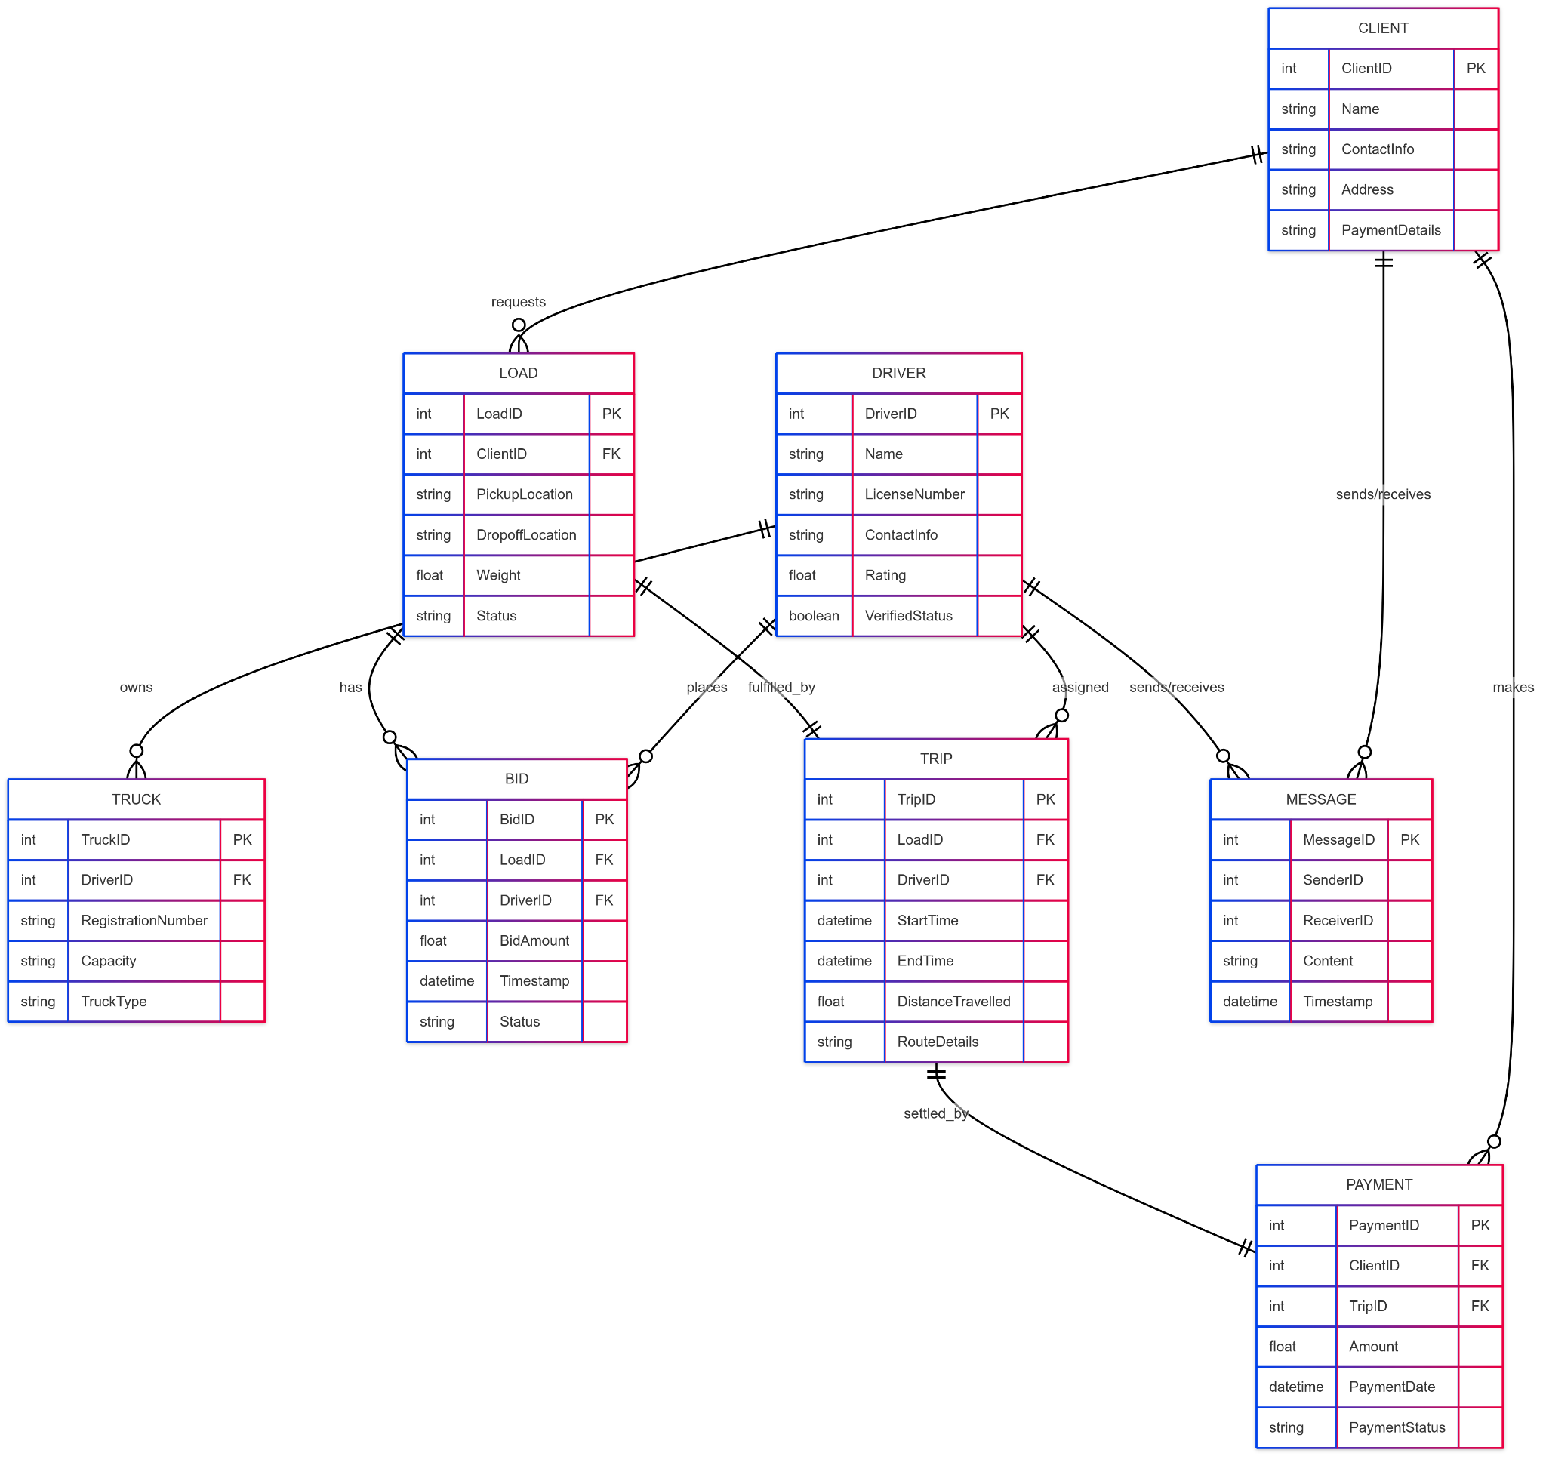

4.3.2 Normalized Databases

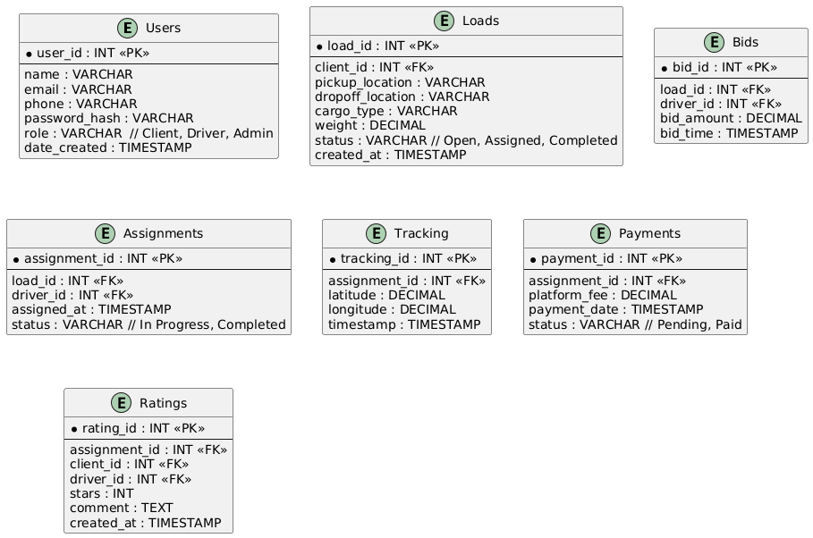

4.4 Program Design
4.1 Class Diagram
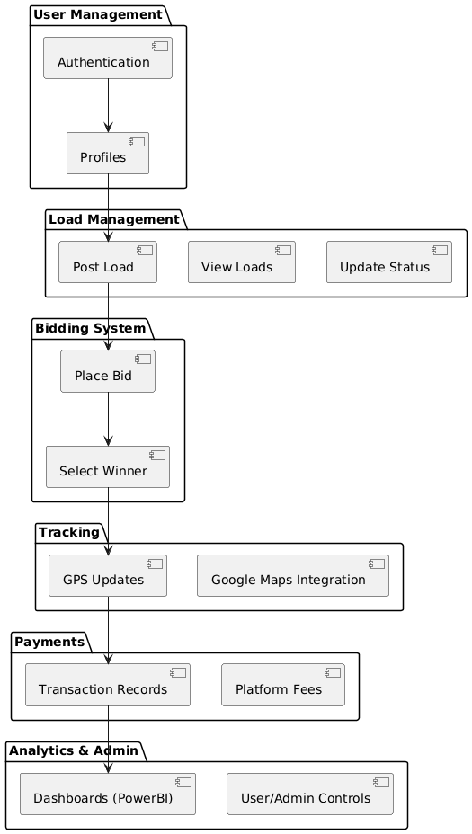

4.2 Sequence Diagram
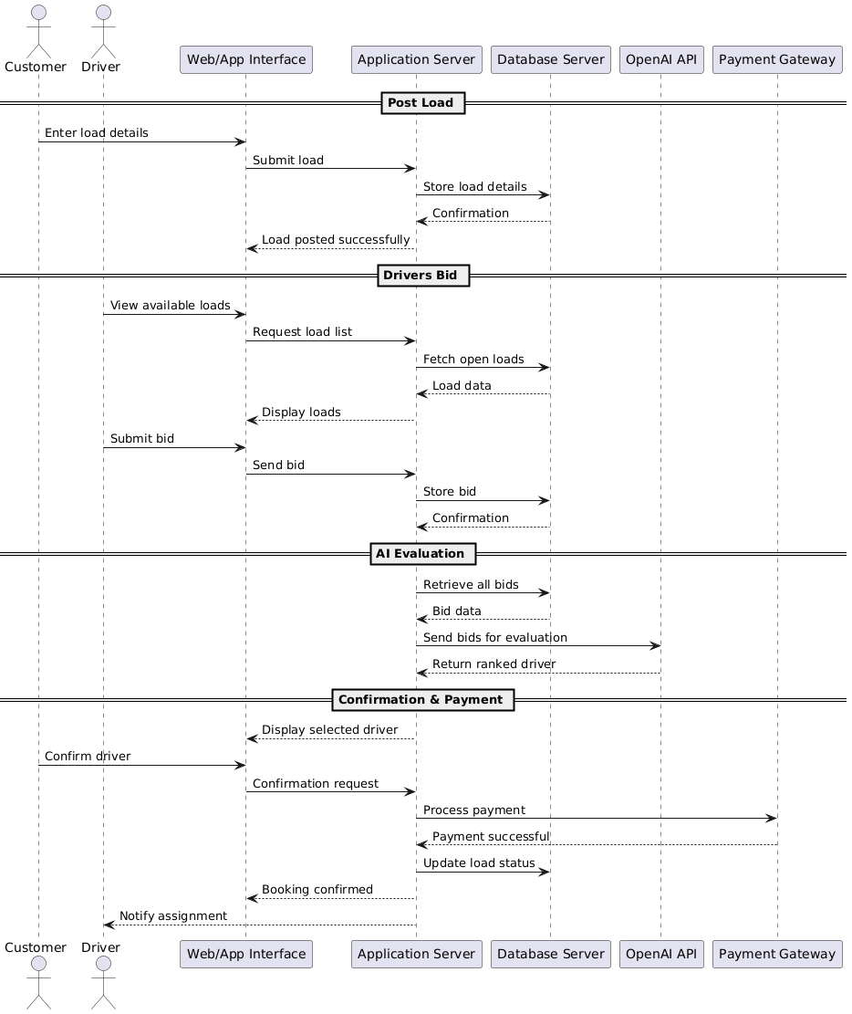

5.0 Package Diagrams
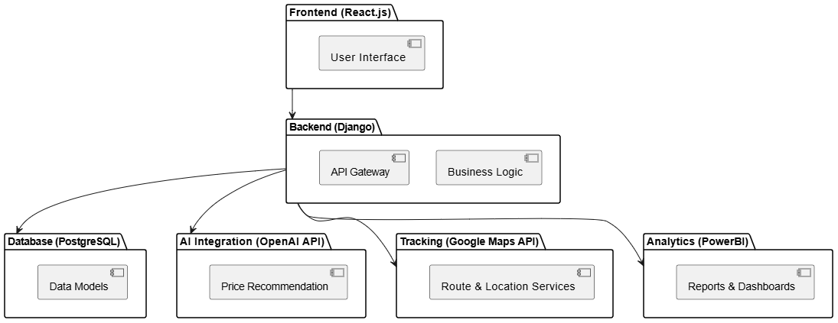

6.1 PSEUDO CODE

Algorithm 1: AI Price Recommendation Engine
Purpose: To calculate a fair market base price when a client posts a load, reducing negotiation time.
FUNCTION RecommendPrice(loadDetails)
// Inputs: loadDetails (Origin, Destination, Weight, CargoType)
// Output: RecommendedPrice (Float)

BEGIN
// 1. Calculate Distance using Google Maps API
distance_km = GoogleMapsAPI.GetDistance(loadDetails.Origin, loadDetails.Destination)

// 2. Fetch Base Rate per km based on Cargo Type (e.g., Perishable, Hazardous, General)
base_rate = Database.GetBaseRate(loadDetails.CargoType)

// 3. Calculate Operational Cost
fuel_cost = distance_km * AverageFuelPricePerKm
wear_tear = distance_km * MaintenanceFactor
operational_cost = fuel_cost + wear_tear

// 4. Apply Demand Surge Pricing (AI Logic)
active_loads = Database.CountActiveLoads(loadDetails.Origin)
active_drivers = Database.CountAvailableDrivers(loadDetails.Origin)

demand_factor = 1.0 // Default

IF active_loads > active_drivers THEN
demand_factor = 1.2 // Increase price by 20% if high demand
ELSE IF active_drivers > (active_loads * 2) THEN
demand_factor = 0.9 // Discount by 10% if oversupply of drivers
END IF

// 5. Calculate Final Recommended Price
estimated_price = (operational_cost + (base_rate * distance_km)) * demand_factor

RETURN Round(estimated_price, 2)
END

Algorithm 2: Intelligent Driver Matching System
Purpose: To find and notify the most suitable drivers for a specific load to ensure quick acceptance and reliability.
FUNCTION MatchDrivers(newLoad)
// Inputs: newLoad (ID, PickupLocation, TruckTypeRequired, PickupDate)
// Output: List of notified drivers

BEGIN
// 1. Retrieve all active, verified drivers
candidate_drivers = Database.Query("SELECT * FROM Drivers WHERE Status='Active' AND Verified='True'")

scored_drivers = []

// 2. Evaluate each driver
FOR EACH driver IN candidate_drivers DO

// Check Vehicle Compatibility
IF driver.VehicleType != newLoad.TruckTypeRequired THEN
CONTINUE // Skip this driver
END IF

// Check Location Proximity (Geospatial analysis)
distance_to_pickup = CalculateDistance(driver.CurrentLocation, newLoad.PickupLocation)

IF distance_to_pickup > 100 THEN
CONTINUE // Skip drivers too far away (e.g., > 100km)
END IF

// 3. Calculate Match Score (0 to 100)
// Weighting: 50% Proximity, 30% Rating, 20% Job History
score = 0
score += (100 - distance_to_pickup) * 0.5 // Closer drivers get higher score
score += (driver.AverageRating / 5.0 * 100) * 0.3
score += (Min(driver.CompletedJobs, 50) / 50 * 100) * 0.2

driver.MatchScore = score
scored_drivers.Add(driver)

END FOR

// 4. Sort and Notify
Sort scored_drivers DESCENDING by MatchScore

// Notify top 10 matches first
top_matches = GetTop(scored_drivers, 10)

FOR EACH driver IN top_matches DO
NotificationService.Send(driver.ID, "New Load Match: " + newLoad.ID)
END FOR

RETURN top_matches
END

Algorithm 3: Bidding & Escrow Transaction
Purpose: To handle the bid acceptance and secure funds before the trip begins
FUNCTION AcceptBid(client_id, bid_id)
BEGIN
// 1. Fetch details
bid = Database.GetBid(bid_id)
load = Database.GetLoad(bid.load_id)
driver = Database.GetDriver(bid.driver_id)
client = Database.GetClient(client_id)

// 2. Validation
IF load.Status != "OPEN" THEN
RETURN Error("Load is already booked.")
END IF

// 3. Process Payment (Escrow Lock)
payment_status = PaymentGateway.HoldFunds(client.PaymentMethod, bid.Amount)

IF payment_status == "SUCCESS" THEN

// 4. Update Database
load.Status = "ASSIGNED"
load.AssignedDriver = driver.ID
load.AgreedPrice = bid.Amount

// Create Trip Record
CreateTrip(load.ID, driver.ID, client.ID)

// 5. Notify Parties
NotificationService.Send(driver.ID, "Bid Accepted! Funds Secured. Proceed to Pickup.")
NotificationService.Send(client.ID, "Driver Confirmed. Payment held in Escrow.")

RETURN Success("Booking Confirmed")

ELSE
RETURN Error("Payment Failed. Insufficient funds.")
END IF
END

4.5 Interface Design

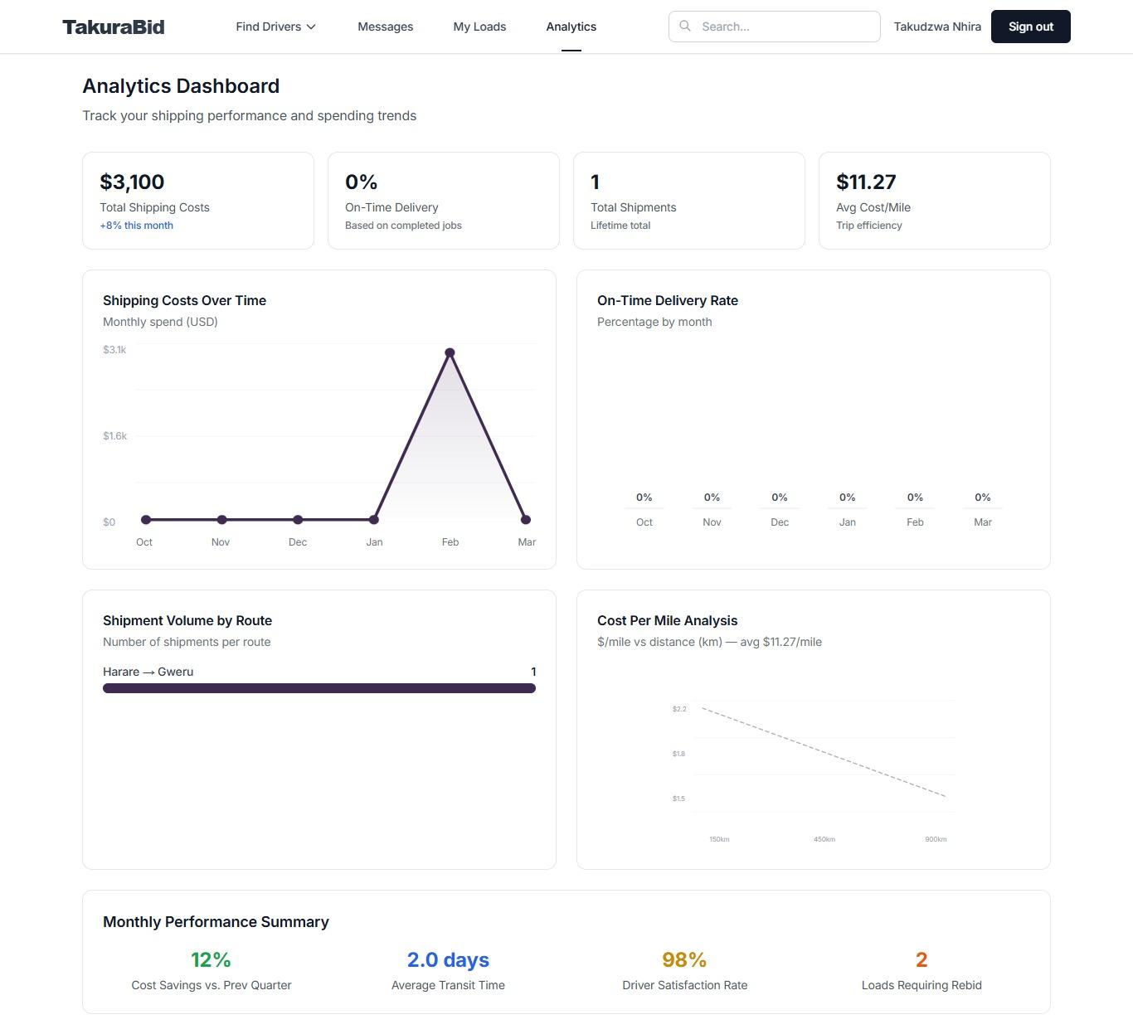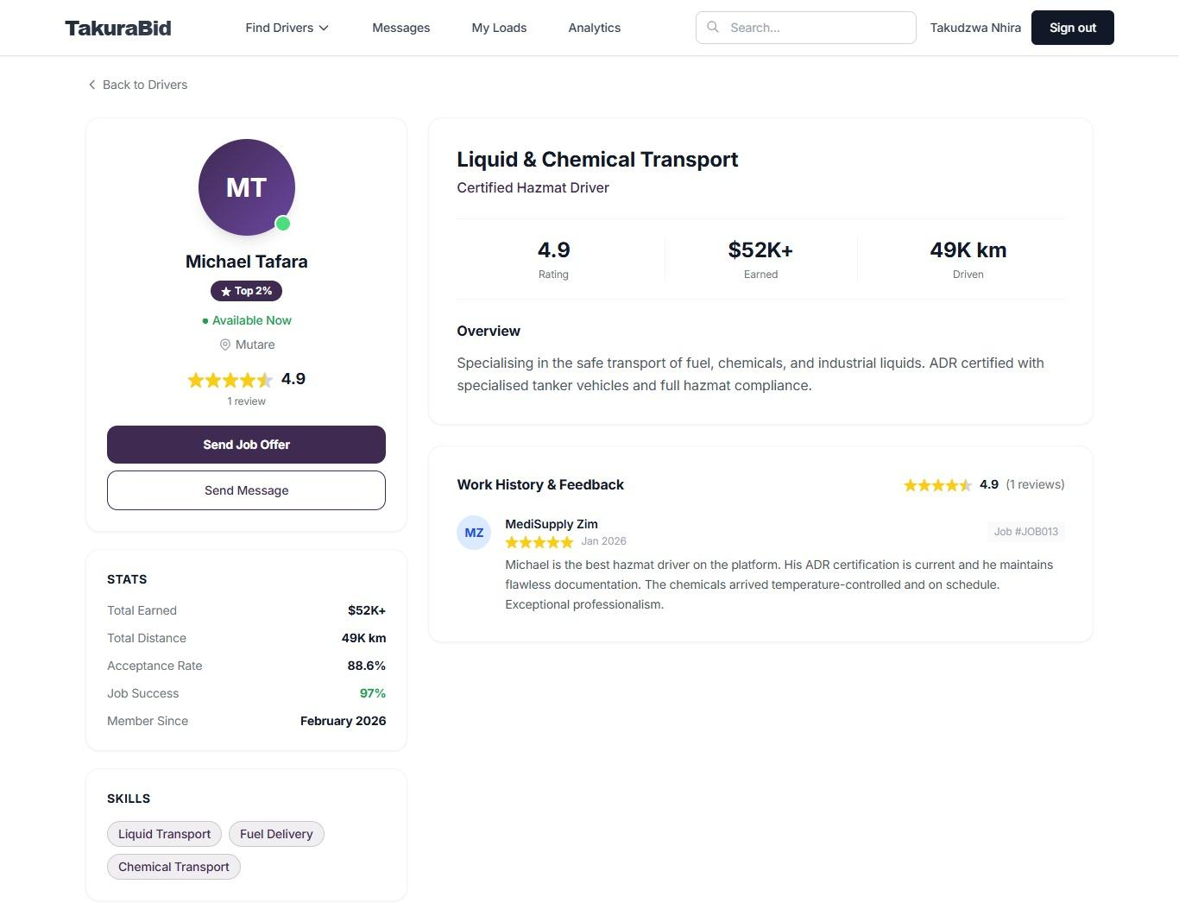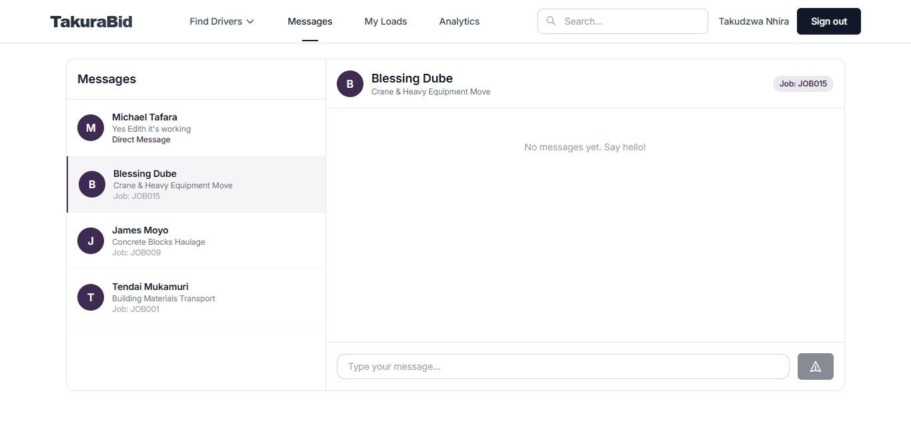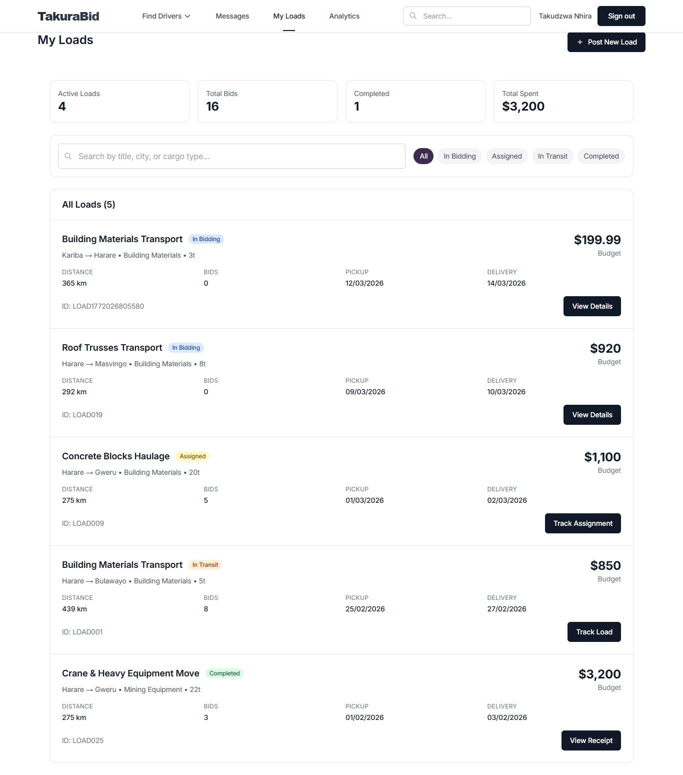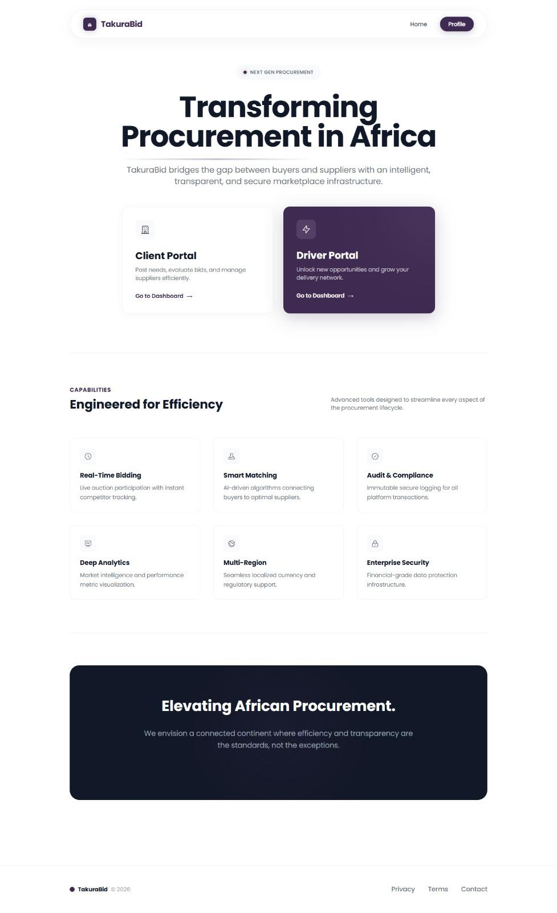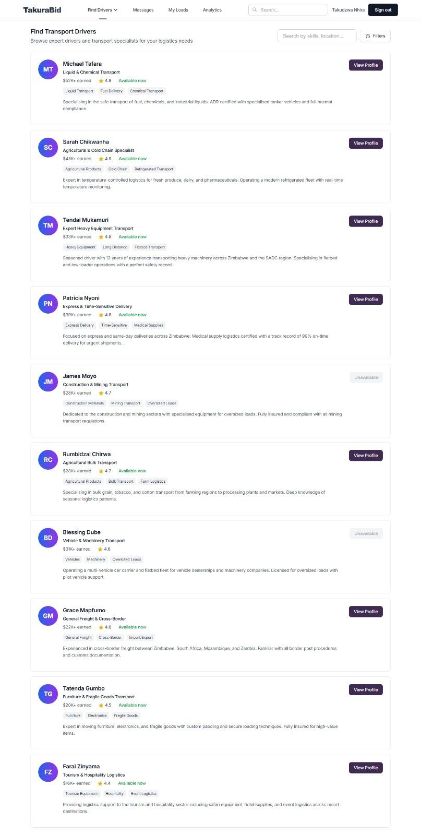

7.1 Conclusion and Recommendations
The TakuraBid project successfully presents a transformative digital solution designed to address the critical inefficiencies plaguing Zimbabwe’s freight and logistics sector. Through a detailed analysis of the current market landscape, it was established that the reliance on manual processes, unregulated intermediaries, and fragmented communication has stifled growth and fostered a lack of trust between shippers and carriers.
The primary objective of developing a secure, transparent, and efficient freight marketplace has been realized through the architectural design of TakuraBid. By leveraging a modern technology stack , comprising React.js for a responsive frontend, Node.js for a scalable backend, and Python-based AI for intelligent price recommendations , the platform offers a robust alternative to traditional logistics models.

The study confirms that TakuraBid is viable across all key feasibility dimensions:
- Technically: The system utilizes proven, secure technologies (AES-256 encryption, WebSockets) that ensure data integrity and real-time performance.
- Economically: By reducing "empty leg" journeys and eliminating predatory broker fees, the platform creates clear financial value for independent drivers and SMEs, projecting long-term sustainability.
- Operationally: The intuitive design caters to the local context, ensuring ease of adoption for drivers accustomed to mobile technology, thereby bridging the digital divide in the transport sector.
In summary, TakuraBid is not merely a software application but a strategic infrastructure tool. It empowers individual truck drivers, provides cost transparency for clients, and contributes to the modernization of Zimbabwe’s economy. The project stands as a testament to the power of digital innovation in solving real-world industrial challenges.

7.2 Recommendations
To ensure the successful long-term deployment and scaling of TakuraBid, the following recommendations are proposed:
- Mobile-First Optimization: Given that the majority of truck drivers rely on smartphones, future development should prioritize a dedicated mobile application (Android/iOS) with offline capabilities to handle areas with poor connectivity.
- Strategic Partnerships: The platform should seek partnerships with insurance companies and fuel suppliers to offer value-added services to verified drivers, further incentivizing platform adoption.
- Advanced AI Integration: As the dataset grows, the AI model should be retrained to include predictive maintenance alerts for drivers and demand forecasting for fleet owners.
- Regulatory Compliance: Continuous engagement with the Ministry of Transport and the Reserve Bank of Zimbabwe is essential to ensure the platform’s payment and operational frameworks remain compliant with evolving national regulations.

7.3 Future Work
Future iterations of the project will focus on expanding the logistics ecosystem to include cross-border freight management, integrating blockchain for immutable supply chain records, and developing a "Pool-a-Truck" feature for smaller cargo consolidation. These enhancements will further solidify TakuraBid’s position as a market leader in digital logistics.

